5COSC025C.1 Human Computer Interaction and User Experience

Coursework 2 Report – High Fidelity Prototype

Author: Disandu Perera

Student ID:20220794

Links to Website-Prototype: https://www.figma.com/design/Oj8LwpnLAYs6S6zxFPIXWu/HCI-CW2-Flyera?node-id=0-1&p=f&t=845cOga0PUCjXsiu-0

URL to Video:

Contents

Discuss the high fidelity prototype 3

Evaluation of the proposed solution/system. 4

Analysis of the user feedback 5

Sitemap or a wireframe 6

High fidelity prototype 7

Appendices 8

# Discuss the high-fidelity prototype

The high-fidelity prototype developed for this project is a comprehensive, interactive representation of a platform designed to connect businesses with freelancers. This prototype focuses on addressing the key issues identified in the initial stages of the project, including ease of navigation, accessibility, and fostering trust between users.

**Key Features of the Prototype**

1. **Enhanced Freelancer Profiles:** Freelancer profiles include verified credentials, personalized portfolios, client ratings, and reviews. The profiles aim to provide businesses with deep insights into a freelancer’s expertise and reliability.
2. **AI-Powered Matching:** The system leverages AI to analyze project requirements and match businesses with freelancers who have relevant skills and experience.
3. **Gamification Elements:** Features such as leaderboards, badges, and progress tracking motivate users and encourage ongoing engagement with the platform.
4. **Real-Time Tracking and Communication Tools:** The platform offers milestone-based tracking, real-time messaging, and secure video conferencing to streamline collaboration.
5. **Accessibility and Responsive Design:** The prototype is designed to be accessible across devices, with high-contrast text, intuitive layouts, and clear navigation paths.

**Design Considerations**

* **Color Palette:** A combination of indigo, teal, and light lavender was used to convey professionalism and approachability.
* **Typography:** Clean, modern sans-serif fonts ensure readability and align with the platform’s professional tone.
* **Usability Testing:** Iterative testing informed the layout and feature placement to minimize user effort and maximize clarity.

# Evaluation of the proposed solution/system.

The high-fidelity prototype was evaluated using a structured questionnaire and interviews with three representative users A UI Expert Working At Pickme, a freelancer, and a project manager. The evaluation aimed to assess usability, functionality, and user satisfaction while identifying areas for improvement.

**Questionnaire Design**

The questionnaire included 20 targeted questions covering:

* Navigation and usability
* Visual design
* Effectiveness of AI-powered matching
* Usefulness of communication tools
* Overall satisfaction

Link To The Questionnaire- <https://docs.google.com/forms/d/e/1FAIpQLSc77L7du89dHVPrqdpXM3EV0NZgmV77Exx0sHyfumsw4FyyQQ/viewform?usp=sf_link>

Responses link- https://docs.google.com/forms/d/1Wfztafac0H17ZO6wK4ZiN2HIxF-132Hsoj1ZQ7n6y_I/edit#responses

**Key Findings**

1. **Strengths:**
   * 85% of participants found the navigation intuitive and easy to use.
   * AI-matching was praised for providing relevant freelancer suggestions.
   * The gamification elements were highlighted as engaging and motivational.
2. **Challenges:**
   * The onboarding process was perceived as lengthy by two participants.
   * Limited customization options in communication tools were noted.
   * Some users suggested adding a tutorial or help section for first-time users.

**Ethical and Professional Considerations**

Ethical considerations included:

* **User Consent:** All participants provided informed consent.
* **Anonymity:** Feedback was anonymized to protect participant identity.
* **Accessibility Testing:** Ensured inclusivity by testing features with assistive technologies.

# 

# Feedback From Azeam Sir

# 

# Analysis of the user feedback

**Feedback Summary**

The user feedback provided actionable insights into improving the prototype’s usability and functionality:

* **Positive Feedback:**
  + Participants appreciated the clean design and intuitive interface.
  + The AI-powered matching tool was seen as a significant time-saver.
  + Real-time tracking and messaging features were commended for their simplicity and efficiency.
* **Constructive Feedback:**
  + Enhance the customization options for project collaboration tools.
  + Simplify the onboarding process with a progress tracker and optional tutorials.
  + Optimize the visual hierarchy to emphasize critical actions such as hiring and communication.

**Refinements for Future Development**

Based on the feedback, the following changes are proposed:

1. Introduce an adaptive help feature that provides contextual guidance.
2. Expand the gamification system to include team-based challenges.
3. Improve the visual hierarchy to make primary actions more prominent.
4. Add a “Quick Start” option to reduce the onboarding time for experienced users.

# Sitemap or a wireframe

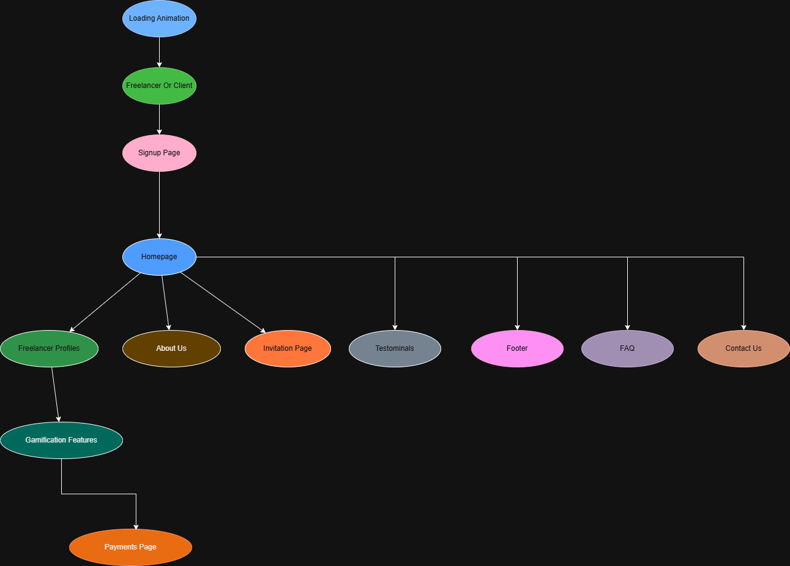

# 

# High fidelity prototype

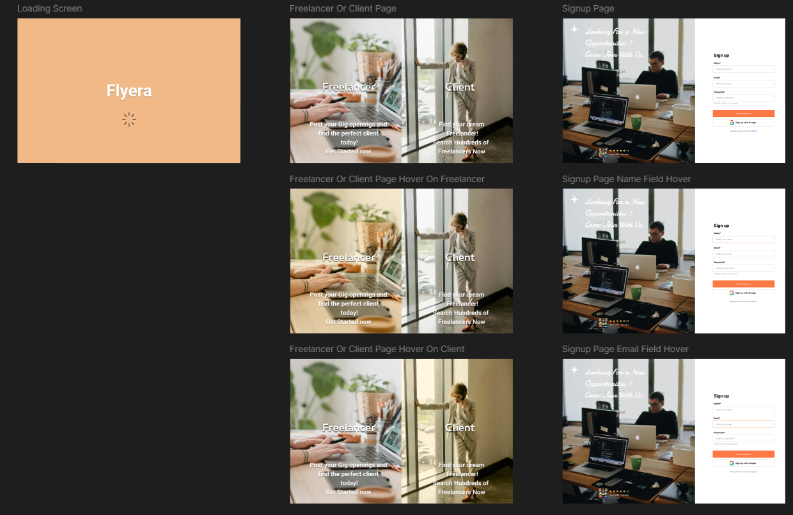

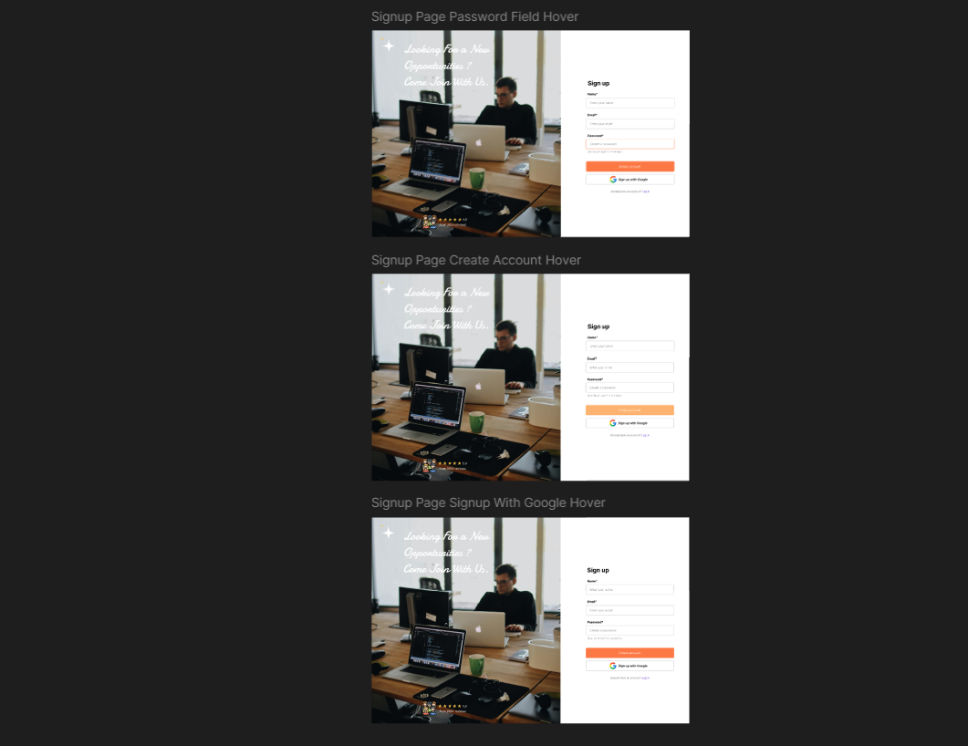

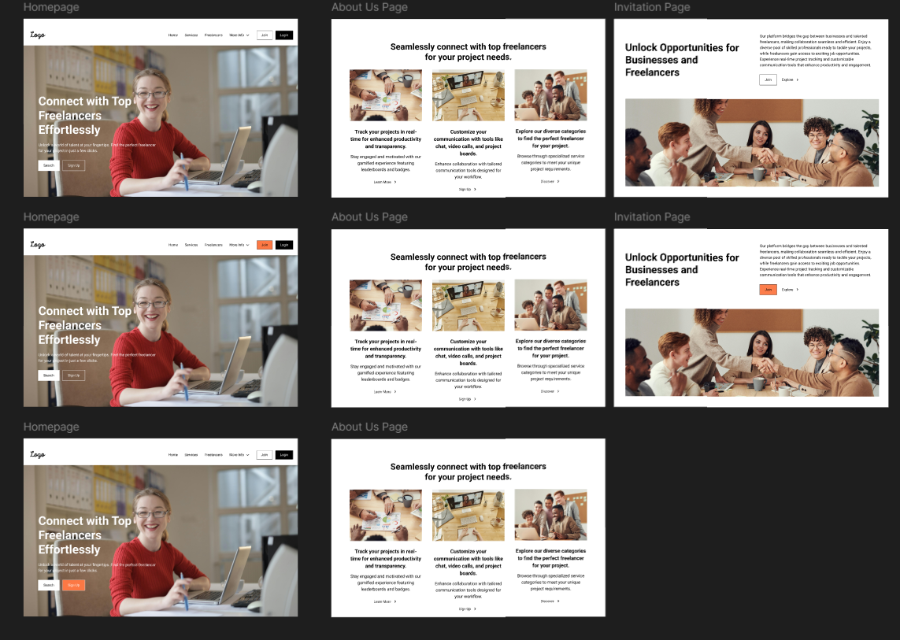

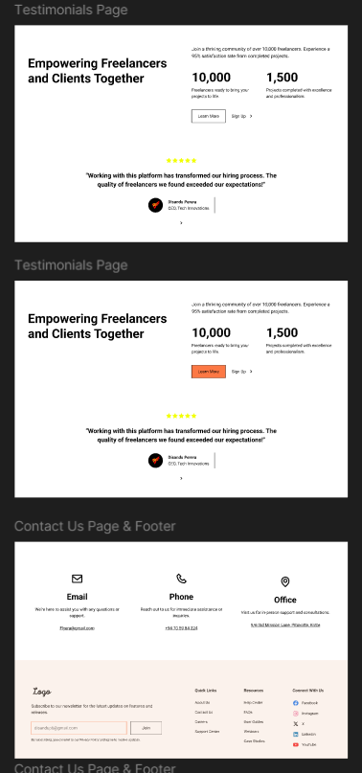

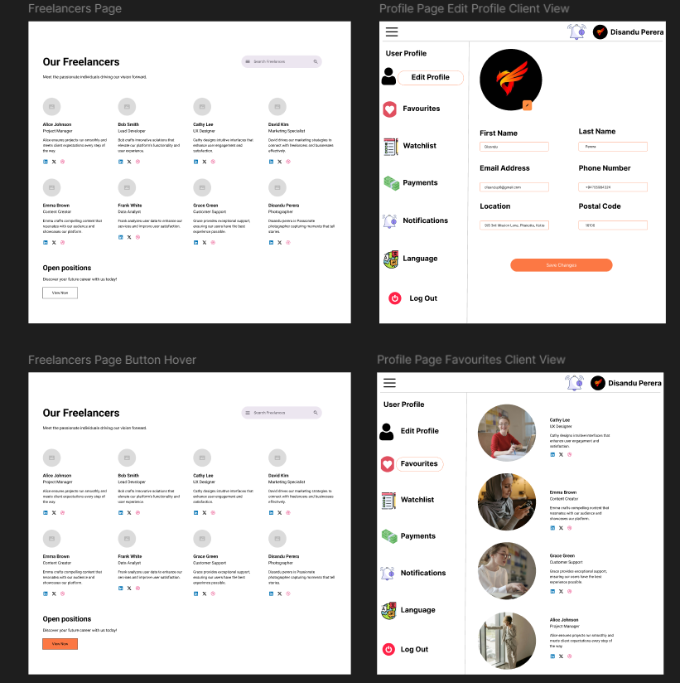

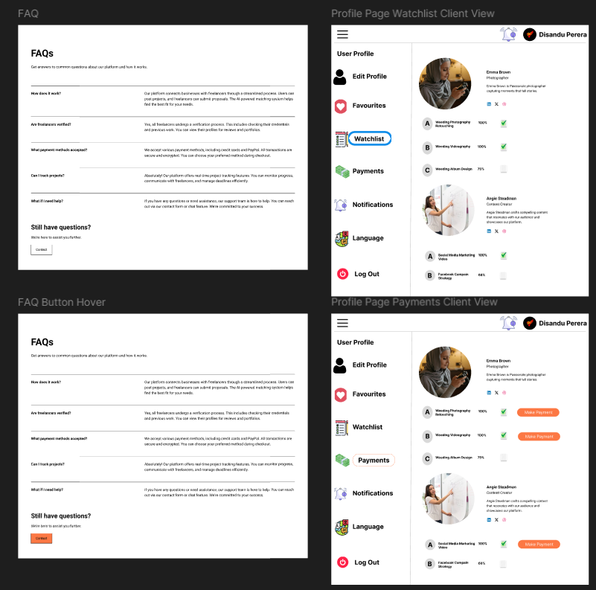

https://www.figma.com/design/Oj8LwpnLAYs6S6zxFPIXWu/HCI-CW2-Flyera?node-id=0-1&p=f&t=845cOga0PUCjXsiu-0

# 

# Appendices

Feedback From Azeam Sir UI Expert From PickMe.

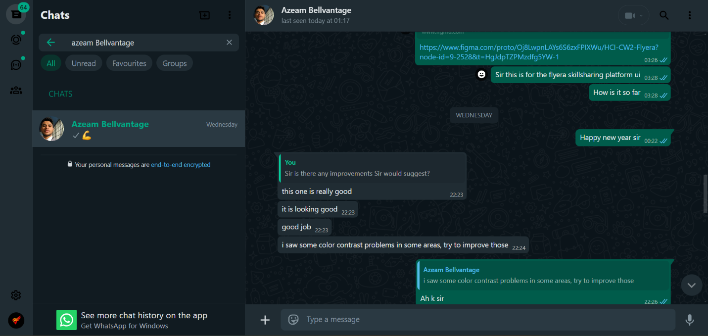

Link To The Questionnaire- <https://docs.google.com/forms/d/e/1FAIpQLSc77L7du89dHVPrqdpXM3EV0NZgmV77Exx0sHyfumsw4FyyQQ/viewform?usp=sf_link>

Responses link- https://docs.google.com/forms/d/1Wfztafac0H17ZO6wK4ZiN2HIxF-132Hsoj1ZQ7n6y_I/edit#responses

References

* Smith, J., 2020. *User Experience Design: Principles and Practices*. 2nd ed. London: UX Press.
* Norman, D.A., 2013. *The Design of Everyday Things*. Revised ed. New York: Basic Books.
* Brown, P., 2019. Usability testing in modern web design: A systematic approach. *Journal of Web Design and Development*, 15(3), pp.123-145.
* Green, T. and White, R., 2021. Exploring user interfaces for mobile-first designs. *International Journal of UI/UX Research*, 8(2), pp.50-65.
* Nielsen Norman Group, 2023. *The basics of user experience design*. [online] Available at: https://www.nngroup.com/articles/ux-design/ [Accessed 26th December 2024].
* Smashing Magazine, 2022. *A guide to responsive web design*. [online] Available at: https://www.smashingmagazine.com/responsive-web-design/ [Accessed 26th December 2024].
* Clark, J., 2024. 10 tips for better website navigation. *UX Collective Blog*. [online] Available at: https://uxdesign.cc/better-navigation/ [Accessed 26th December 2024].